Assignment: 05

Title: Suffix Tree

Introduction
A Suffix Tree is a specialized tree-based data structure used for efficient string processing and pattern matching. It represents all suffixes of a given string in a compressed trie-like structure. Suffix trees are widely used in bioinformatics, text processing, data compression, and computational linguistics because they enable fast searching and analysis of large sequences.
In bioinformatics, DNA, RNA, and protein sequences can be extremely long. Searching for patterns, motifs, repeated subsequences, or similarities within these sequences using traditional methods can be computationally expensive. The suffix tree provides an efficient solution by organizing all suffixes of a sequence into a hierarchical structure, allowing many string operations to be performed in linear time.
A suffix of a string is any substring that starts at a particular position and extends to the end of the string. For example, the string "BANANA$" has the following suffixes:
- BANANA$
- ANANA$
- NANA$
- ANA$
- NA$
- A$
- $
A suffix tree stores all these suffixes in a compact form, reducing redundancy and improving search efficiency.
The suffix tree was first introduced by Peter Weiner in 1973 and later improved by several researchers. Today, it is one of the most important data structures in computational biology and sequence analysis.
Applications of suffix trees include:
- DNA and protein sequence matching
- Genome assembly
- Motif finding
- Longest common substring detection
- Data compression
- Plagiarism detection
- Pattern searching in large texts

Draw & Explanation

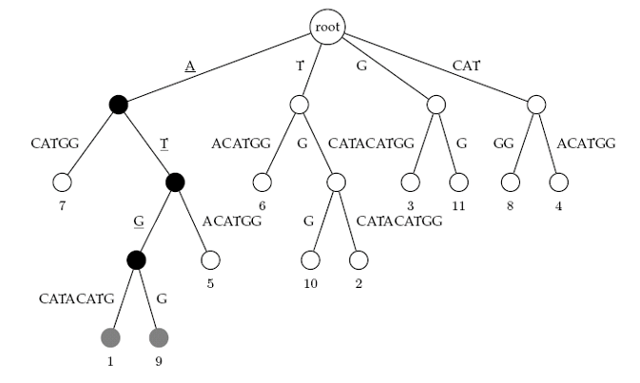

Fig 1: Suffix tree for the text ATGCATACATGG

Step-by-Step Explanation of the Suffix Tree
The suffix tree is built for the text:
ATGCATACATGG

Step 1: Generate All Suffixes
A suffix is a substring that starts at a position and continues to the end of the string.
Position | Suffix
1 | ATGCATACATGG
2 | TGCATACATGG
3 | GCATACATGG
4 | CATACATGG
5 | ATACATGG
6 | TACATGG
7 | ACATGG
8 | CATGG
9 | ATGG
10 | TGG
11 | GG
12 | G
These suffixes are stored in a compressed tree structure.

Step 2: Build the First Level
Look at the first character of each suffix.

Starting with A
- ATGCATACATGG
- ATACATGG
- ACATGG
- ATGG

Starting with T
- TGCATACATGG
- TACATGG
- TGG

Starting with G
- GCATACATGG
- GG
- G

Starting with C
- CATACATGG
- CATGG
Notice that both suffixes starting with C begin with "CAT", so they are compressed into a single edge labeled CAT.
Step 3: Expand the A Branch
Suffixes beginning with A:
ATGCATACATGG
ATACATGG
ACATGG
ATGG
Among them:
- Three begin with AT
- One begins with AC
The leaf labeled 7 corresponds to:
ACATGG
which starts at position 7.
Step 4: Expand the AT Branch
Remaining suffixes:
ATGCATACATGG
ATACATGG
ATGG
After "AT":
- Two continue with G
- One continues with ACATGG
The leaf labeled 5 corresponds to:
ATACATGG
which starts at position 5.
Step 5: Expand the ATG Branch
Now we have:
ATGCATACATGG
ATGG
Both share "ATG".
After ATG:
- One continues as CATACATGG
- One ends as G
These become leaf nodes:
Position 1
Position 9
which are highlighted in gray.
Step 6: Pattern Search for "ATG"
The figure demonstrates searching for:
Pattern = ATG

Move 1
Start at Root.
Root → A
Pattern remaining: TG
Move 2
Follow edge:
A → T
Pattern remaining: G

Move 3
Follow edge:
T → G
Pattern completely matched.
ATG

Step 7: Find All Occurrences

Once the pattern is matched, collect all leaf nodes below the matched node.
ATG occurs at positions:
1 and 9

Step 8: Verify in Original Text
Text:
ATGCATACATGG

Position 1
ATGCATACATGG
^^^
ATG
Match found.

Position 9
ATGCATACATGG
^^^
ATG
Match found.
The suffix tree stores all suffixes of the text in a compressed form. To search for a pattern:
- Start from the root.
- Follow the path matching the pattern characters.
- If the entire pattern is matched, collect all leaf nodes below that point.
- Those leaf nodes give the starting positions of the pattern in the text.
For the pattern ATG, the traversal:
Root → A → T → G
leads to leaf nodes 1 and 9, showing that ATG appears twice in the text ATGCATACATGG. This is why suffix trees are extremely useful in bioinformatics for fast DNA and protein sequence searching.

Advantages and Disadvantages

Advantages
- Fast pattern matching with O(m) search time.
- Efficient storage of repeated substrings through path compression.
- Useful for finding repeated sequences in DNA and proteins.
- Supports many string operations efficiently.
- Can find the longest repeated substring quickly.
- Useful in genome assembly and sequence analysis.
- Enables fast identification of motifs and conserved regions.

Disadvantages
- Requires large memory compared to simple string representations.
- Construction can be complex to implement.
- Difficult to visualize for very long sequences.
- High storage overhead for massive genomic datasets.
- More complicated than alternative structures such as suffix arrays.
Conclusion
The Suffix Tree is a powerful and efficient data structure used for storing and analyzing all suffixes of a given string in a compact form. It plays a significant role in bioinformatics, text processing, and pattern-matching applications because it enables rapid searching and analysis of large sequences. Unlike traditional string-searching methods that may require scanning the entire sequence repeatedly, a suffix tree organizes the data in a hierarchical structure that allows patterns to be located quickly and efficiently.
In this assignment, the concept of the suffix tree was studied using the example string ATGCATACATGG. The construction of the tree demonstrated how common prefixes among suffixes are shared, resulting in a compressed representation that saves space and improves search performance. By tracing the pattern ATG through the suffix tree, it was possible to identify all occurrences of the pattern directly from the leaf nodes without examining every character of the original text. This illustrates one of the key advantages of suffix trees: efficient pattern matching with a time complexity proportional to the length of the pattern rather than the length of the entire text.
Overall, the suffix tree represents an important advancement in string processing and computational biology. Its capability to store all suffixes compactly and support fast pattern matching demonstrates how data structures can be applied to solve complex biological problems. The study of suffix trees provides valuable insight into efficient sequence analysis techniques and highlights the close relationship between computer science and bioinformatics in modern research.

